# **Jump Pads**

Step 1

Before I started to create jump pad:

I used colours

* Red – player
* Dark Blue – platformer

I created a cube shape (from photoshop) in red with two “eyes”. Then I dragged it from photoshop into collide box, which is Unity.

add into the Collider box.

Step 2

Go to the right column, see the bottom “Add Component” and click it. A new drop-down element is formed, type in the game title; “Jump pads”

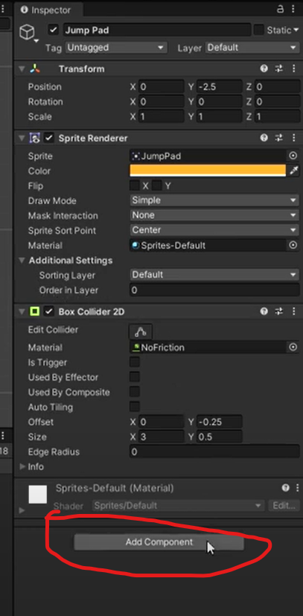

Step 3

Click twice on the title “ Jump Pads,” to Open the new coding drop-down menu.

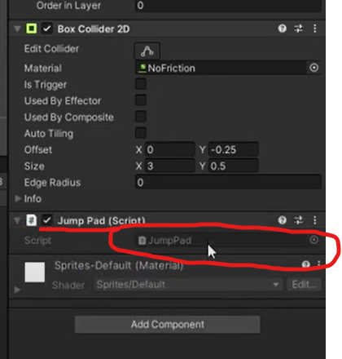

Step 4

See the red – circle area below, delete the contents.

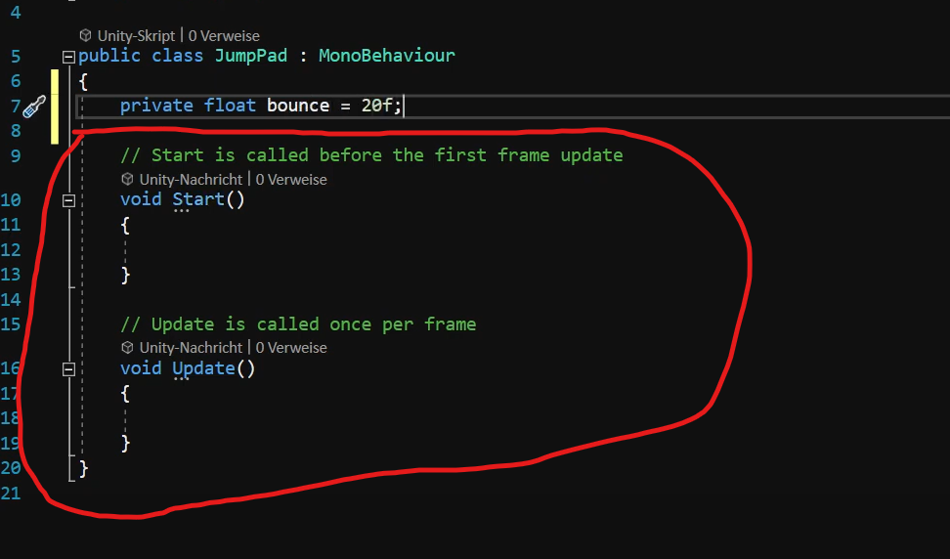

Step 5

In the Same field, insert the coding for Jump Pads as shown below.

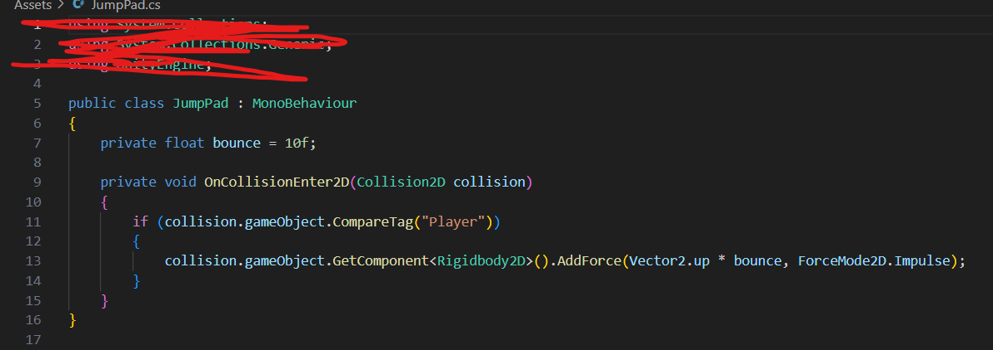

Step 6

Retrum to the Unity webpage, click on the left column under ’Hierarchy’ the layer to create the player.

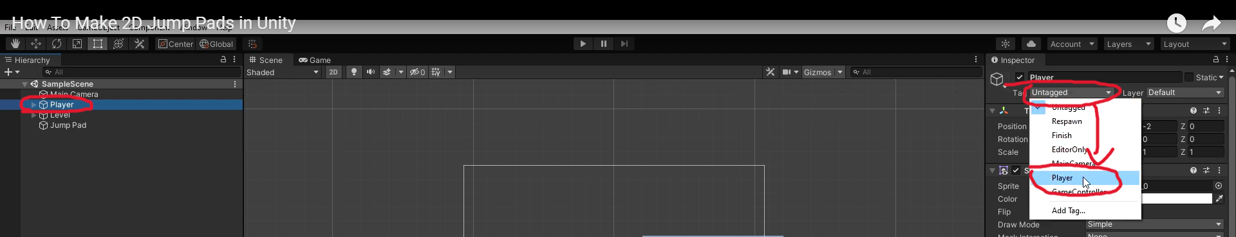

Step 7

Go back and click ‘play’ the Jump Pad process. Check and modify anything which needs correcting, throughout the coding text.